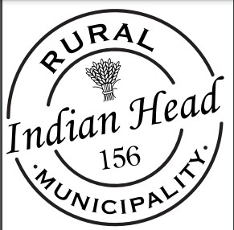

2023 Municipal By-election for the Rural Municipality of Indian Head No. 156

Nomination Date – October 19, 2023
Election Day – November 23, 2023

Candidate Eligibility
Persons eligible for nomination as a candidate in any Saskatchewan municipality must meet all the requirements listed below for the municipality they wish to run in:

Rural Municipality

Candidate MUST

- be at least 18 years old on the day of the election.
- not be disqualified pursuant to this or any other Act.
- be a Canadian citizen at the time that he/she submits the nomination paper.
- have lived in Saskatchewan for at lease six consecutive months immediately preceding the date on which he/she submitted the nomination paper,
- is eligible to vote in the municipality:
- resided in the rural municipality or on land now in the rural municipality for at least three consecutive months immediately preceding the day of the election;
(i.1) is the registered owner of property in the rural municipality, or property now situation in the municipality;
- is the assessed person with respect to property situation in the rural municipality, or property now in the rural municipality, pursuant to section 207 of the Municipalities Act;
- is the occupant of a trailer or mobile home in the municipality that is the object of a permit required pursuant to section 306 of The Municipalitie3s Act;
- is the spouse of a person mention in subclause (ii) or (iii); or
- is the chief executive officer of a duly incorporated co-operative, corporation or religious association that is assessed on the last revised assessment roll with respect to property in the rural municipality that is not exempt from taxation.

